THE UNIVERSITY OF AZAD JAMMU & KASHMIR, MUZAFFARABAD


COURSE TITLE | OS
COURSE CODE | CS-2105
LAB TITLE | INSTALLATION OF VM
STUDENT NAME | HASEEB SHEIKH
STUDENT ROLL NUMBER | 2024-SE-31
INSTRUCTOR NAME | ENGR. SIDRA RAFIQUE
SUBMISSION DATE | OCT 30, 2025

DEPARTMENT OF SOFTWARE ENGINEERING
OS
Lab 3

Objective
To understand the concept of Virtual Machines (VMs) and demonstrate the installation of VMware Workstation Pro on a local machine.

Virtual Machine (VM)
A Virtual Machine is a software-based emulation of a physical computer. It allows users to run multiple operating systems on a single hardware system. VMs are managed by a hypervisor, which allocates resources between the host and guest systems.
Hypervisors
- Bare-metal Hypervisor: Runs directly on hardware (e.g., VMware ESXi, Microsoft Hyper-V).
- Hosted Hypervisor: Runs on top of an existing OS (e.g., VMware Workstation, VirtualBox).
Benefits of Virtual Machines
- Cost-effective and resource-efficient
- Safe environment for testing software
- Isolated from host system for security
- Easy disaster recovery and migration
VMware Workstation Pro
VMware Workstation Pro is a hosted hypervisor that allows users to run multiple virtual environments on a single machine. It is widely used for development, testing, and IT administration.

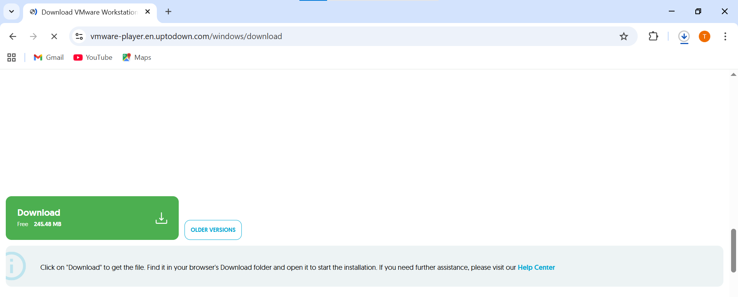

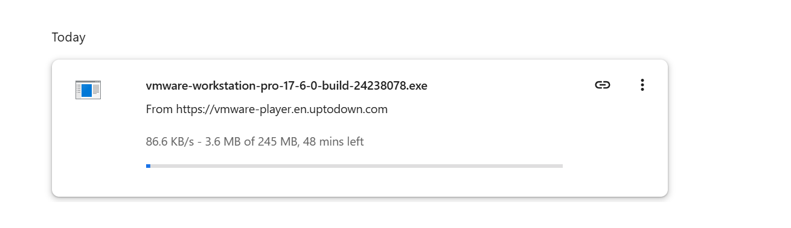

Installation Steps of VMware Workstation Pro
Step 1: Download VMware Workstation Pro
- Visit the official VMware website: https://www.vmware.com
- Navigate to Products → Workstation Pro
- Choose the latest version for Windows and click Download
- Wait for the .exe file to finish downloading

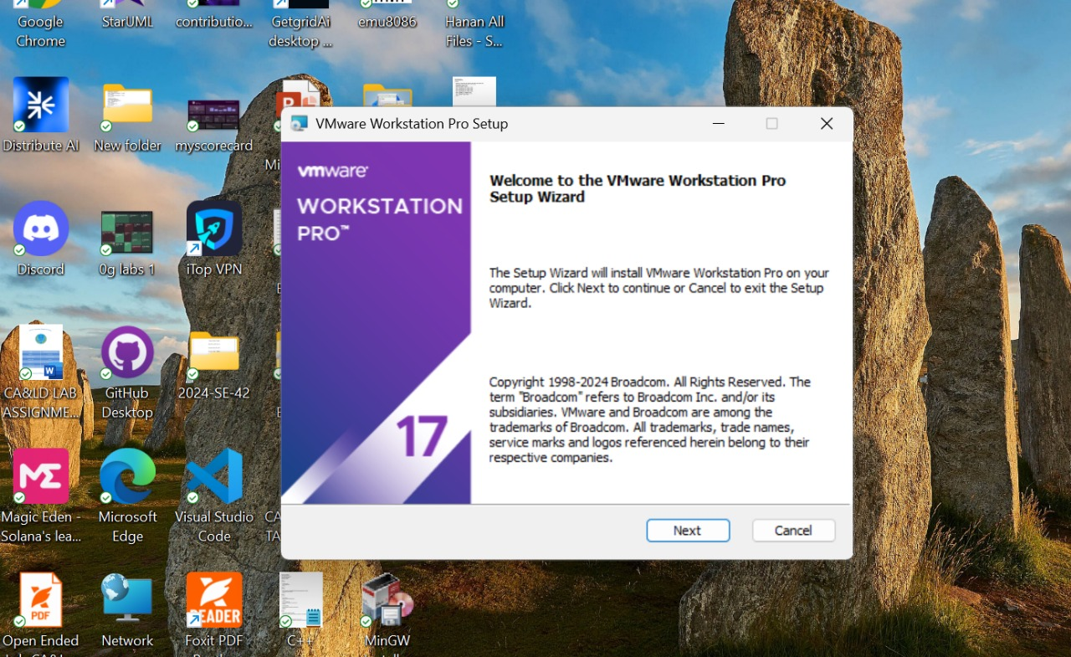

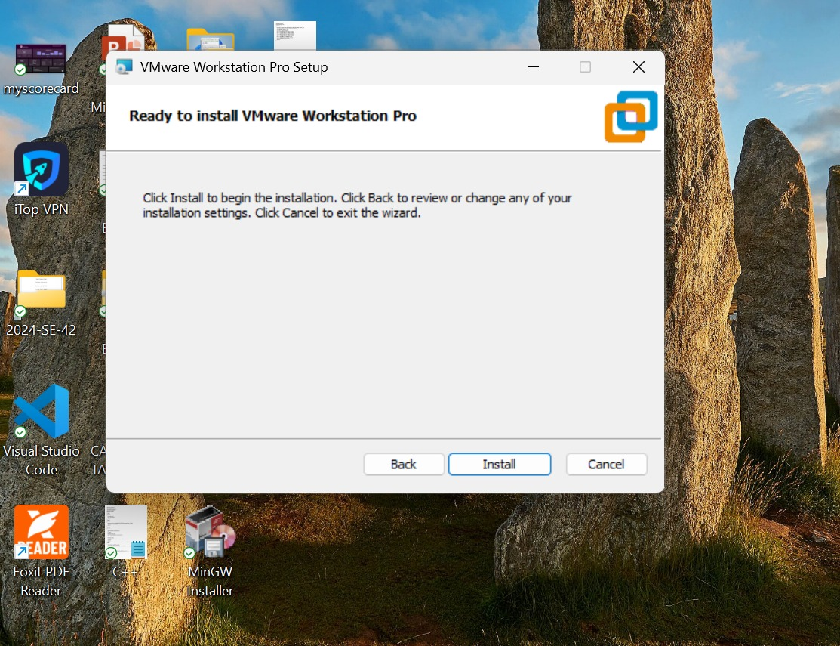

Step 2: Run the Installer
- Locate the downloaded .exe file and double-click to launch
- Click Next to begin setup

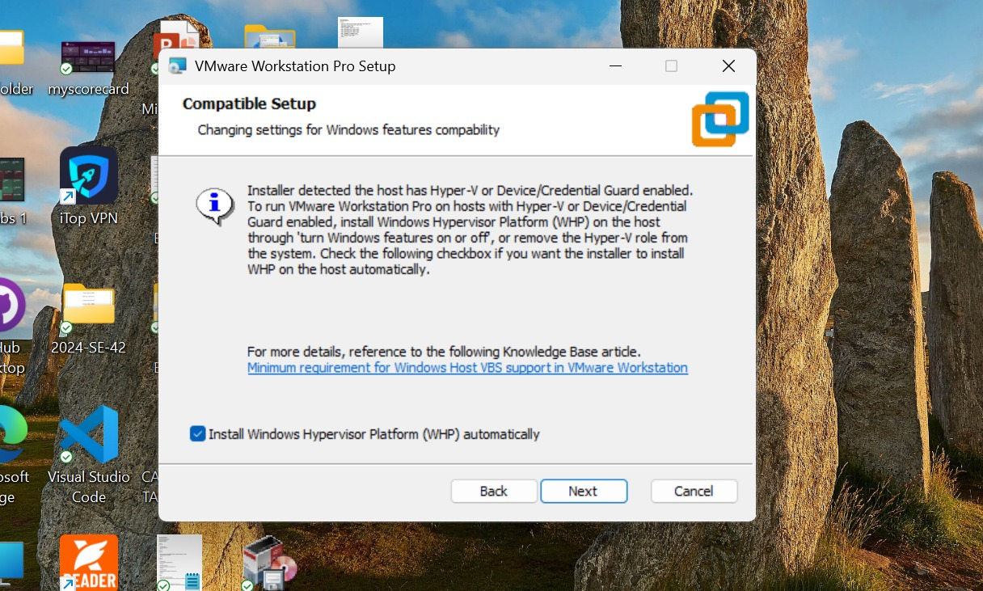

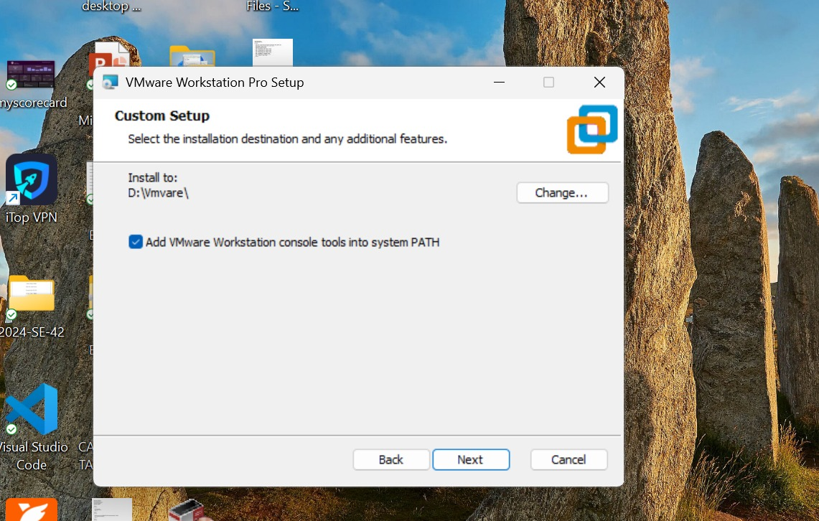

Step 3: Accept License Agreement
- Read and accept the license terms
- Click Next
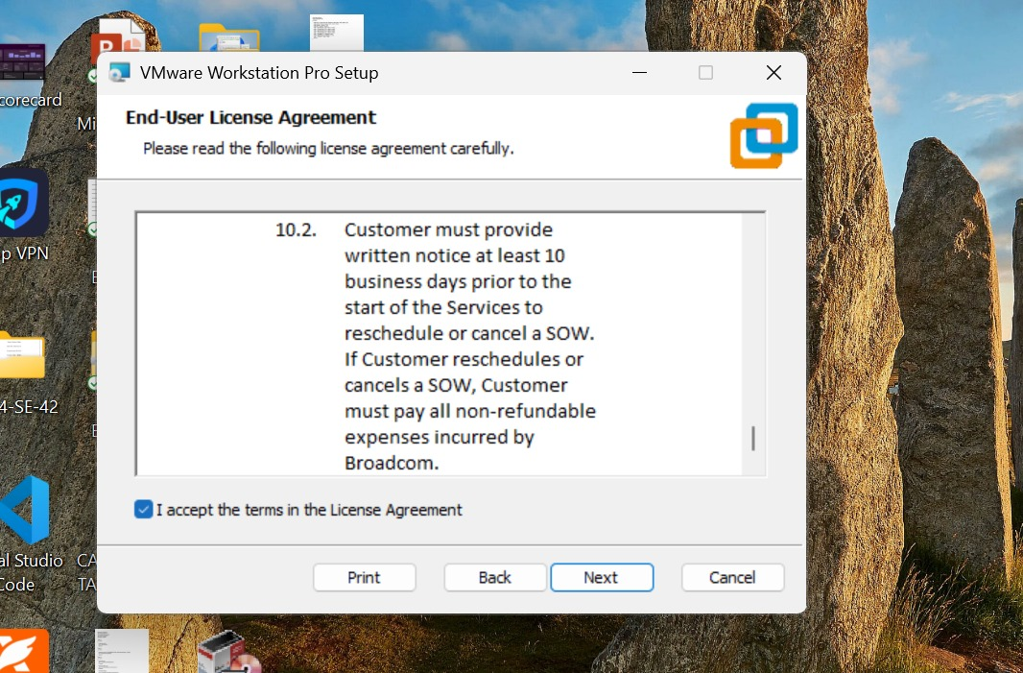

Step 4: Choose Installation Options
- Leave default settings or customize as needed
- Click Next



Step 5: Begin Installation
- Click Install to start the process
- Wait for installation to complete
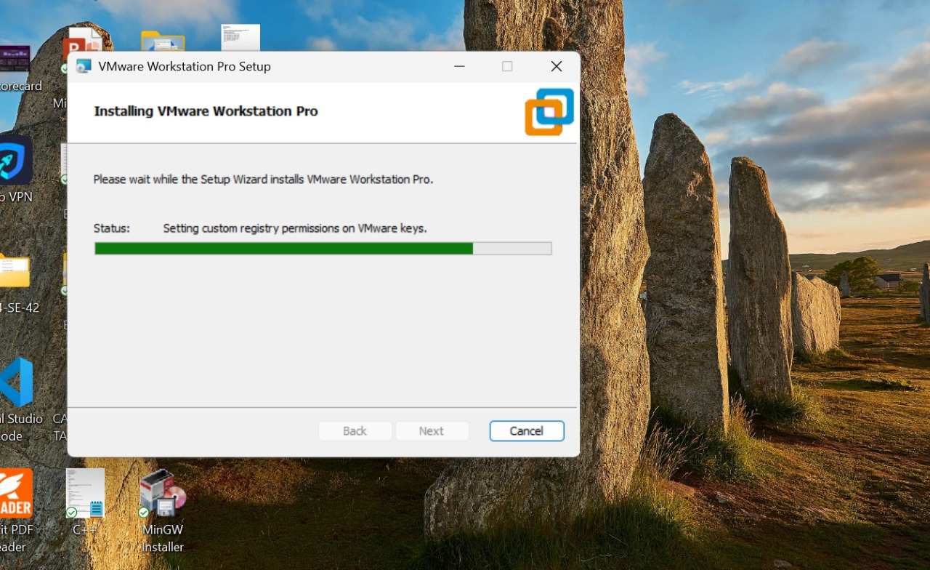

Step 6: Finish Setup
- Click Finish once installation is done
- Launch VMware Workstation Pro from desktop icon

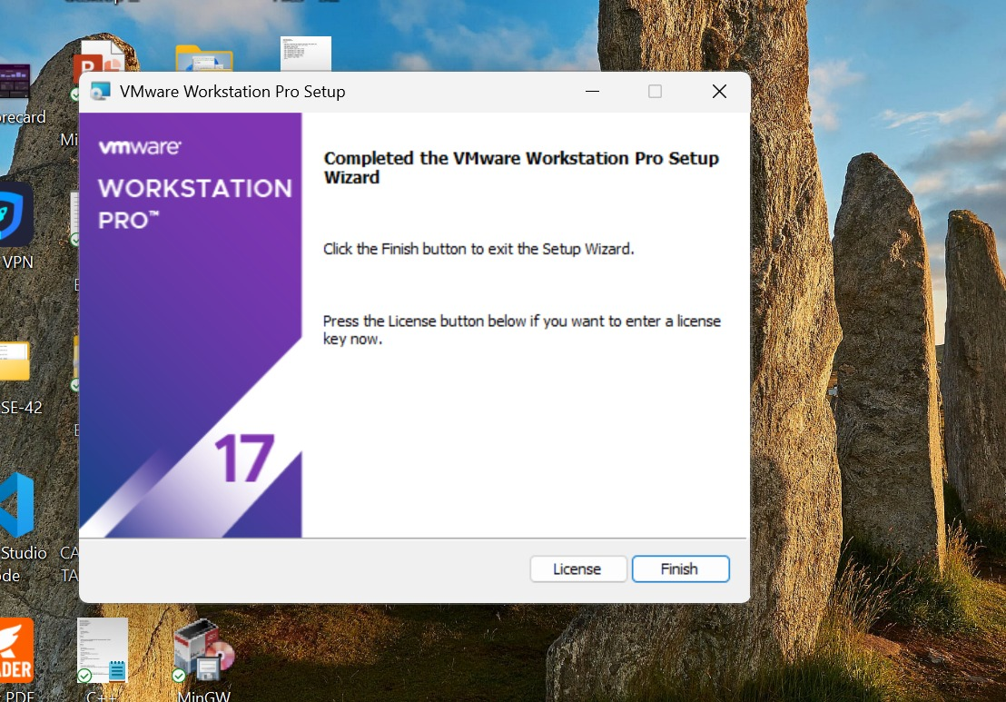

Conclusion
In this lab, we explored the concept of Virtual Machines and installed VMware Workstation Pro. This tool enables us to run multiple operating systems on a single machine, which is essential for testing, development, and learning environments. The installation was successful, and VMware is now ready for creating virtual machines.

